Analysis Toolkit

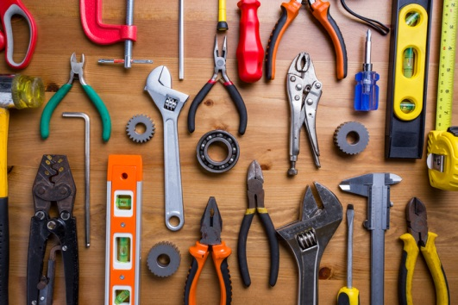

Table of Contents

Needs Analysis

001_Analysis Objectives and Overview

002_Types of Human Resource Development Needs Analysis

003_Training Needs Formula

004_Needs Analysis Chart

005_What Does a Training Needs Analyst Do

006_Training Requisition Form

007_Expected Performance Tools

008_Actual Performance Tools

009_Performance Analysis Overview

010_Performance Analysis Checklist

011_Review Job Performance Records

012_Job Performance Factors

013_Problem_Opportunity Definition Summary

014_Confirm the Cause

015_Propose Solutions Chart

Task Analysis

016_Task Listing

017_Task Analysis Chart

018_Example Task Analysis

Learner Analysis

019_Learner Analysis Worksheets

Other Analysis Tools

020_Administering Surveys

021_Conducting Interviews

022_Example Observation Checklist